User Manual
How to securely share a file



Sharing files Securely Using SpecterX Google Drive Connector

Logging in to the SpecterX web platform
In your browser, visit the SpecterX web app at https://plarium.specterx.com
Please complete the login process using the ‘Sign in with Okta’ button.
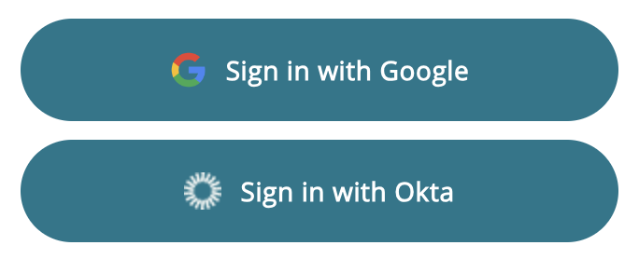

Enable the SpecterX Google Drive connector
Click on the profile picture located in the top right corner of the SpecterX website, then click ‘Connect Google account’
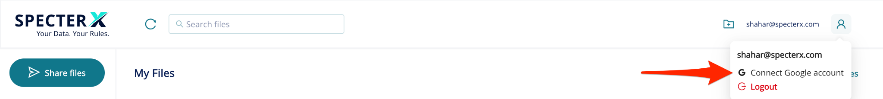

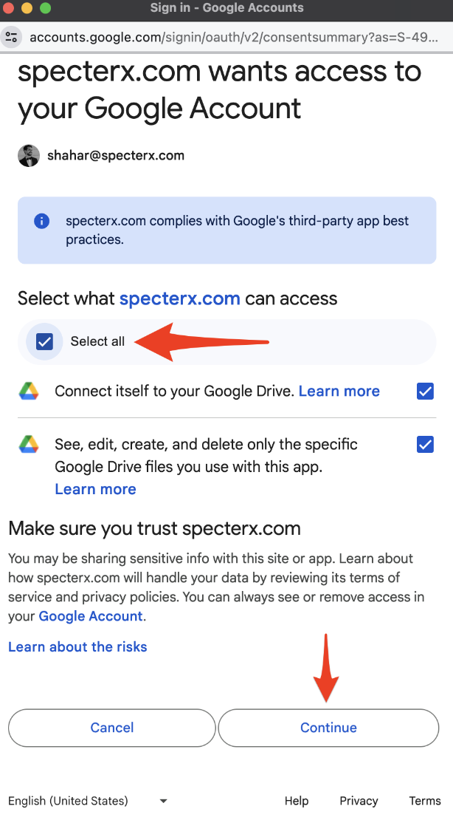
Choose your Google account, click on ‘Select all’ and Continue.
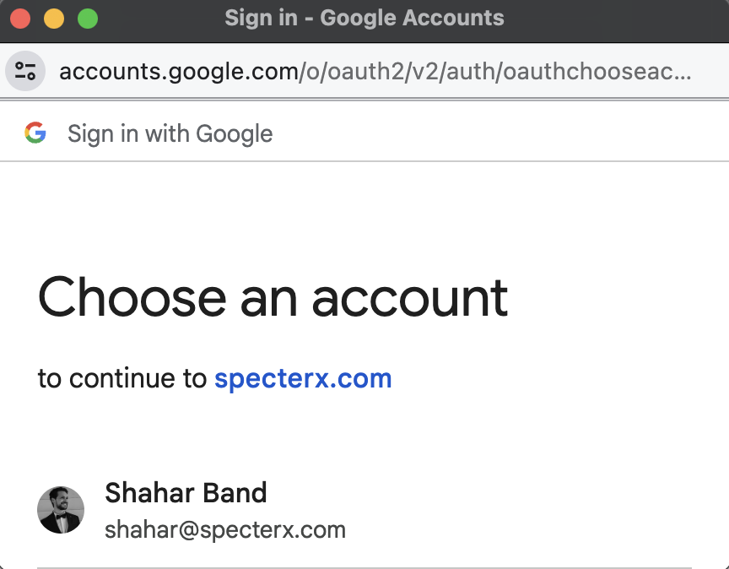

Sharing a file
Right-click on the file you would like to share, choose ‘Open with’, and click on the ‘Share using SpecterX’ button.
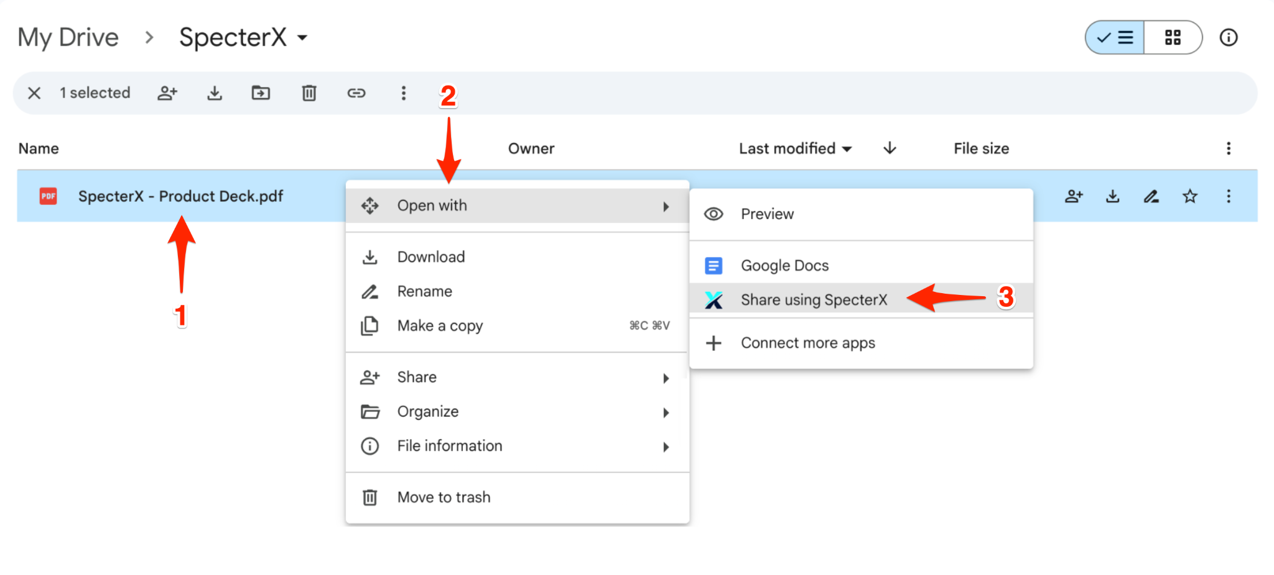
A new window will open where you’ll be prompted to choose:
- The recipient/s email address
- The recipient’s permission level:
  - Viewer - the recipient will only be able to view the shared document
  - Contributor - the recipient will only be able to view and edit the shared document.
  - Co-owner - the recipient will only be able to view, edit and manage the shared document permissions.
- You can adjust the predefined SpecterX policy (Default).
Once done, click on the ‘Share files’ button.

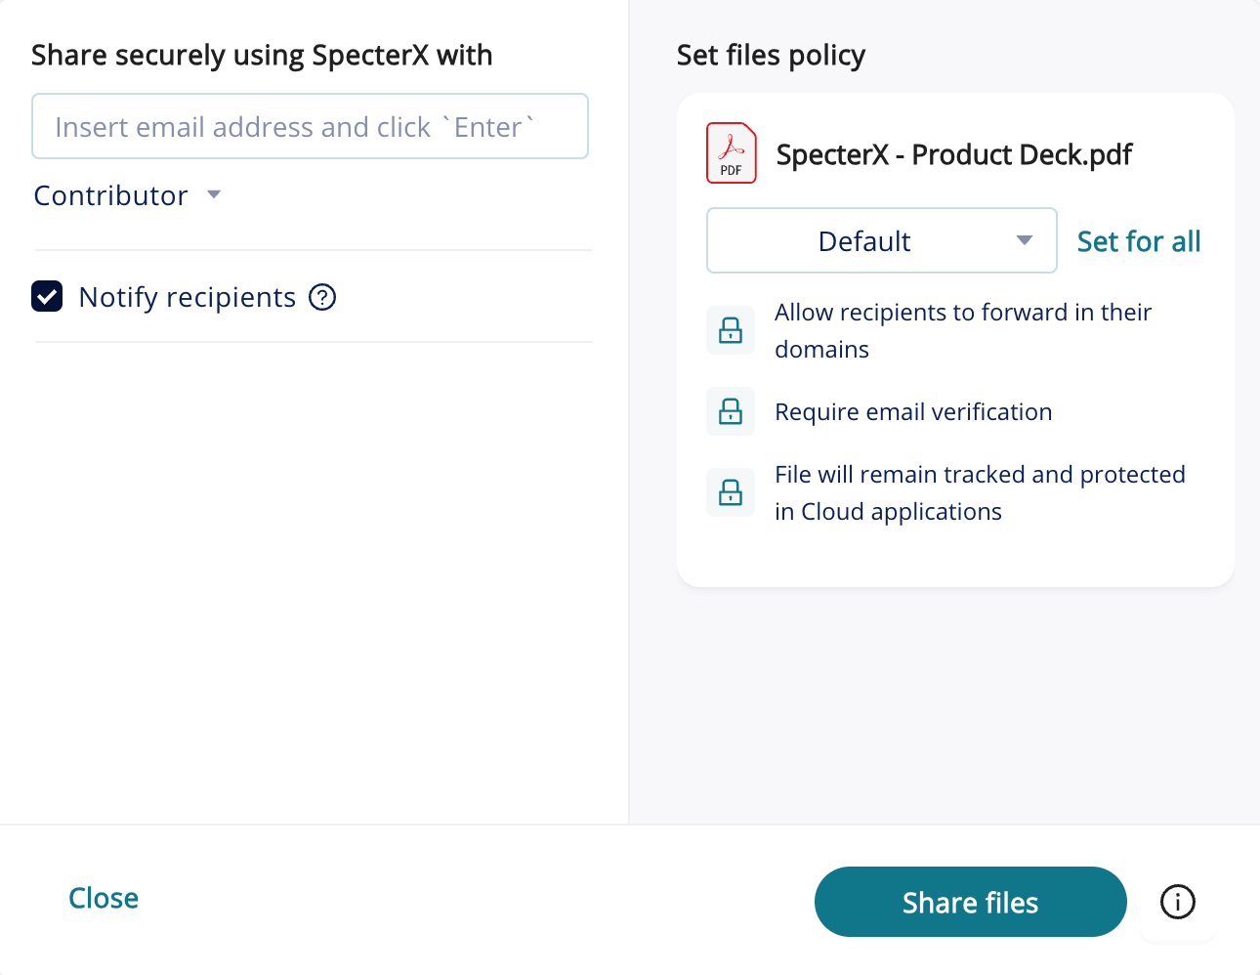
That’s it! You have shared your files successfully.

Sharing files Securely from SpecterX Web Platform

Logging in to the SpecterX web platform
In your browser, visit the SpecterX web app at https://plarium.specterx.com
The identification process will be completed using your corporate identity:


Sharing a file
Click the ‘Share files’ button, placed at the right-hand side of the screen
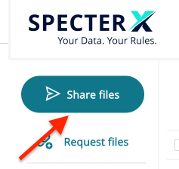

Drag your file/folder to the gray box or click on the box and select the files you would like to share

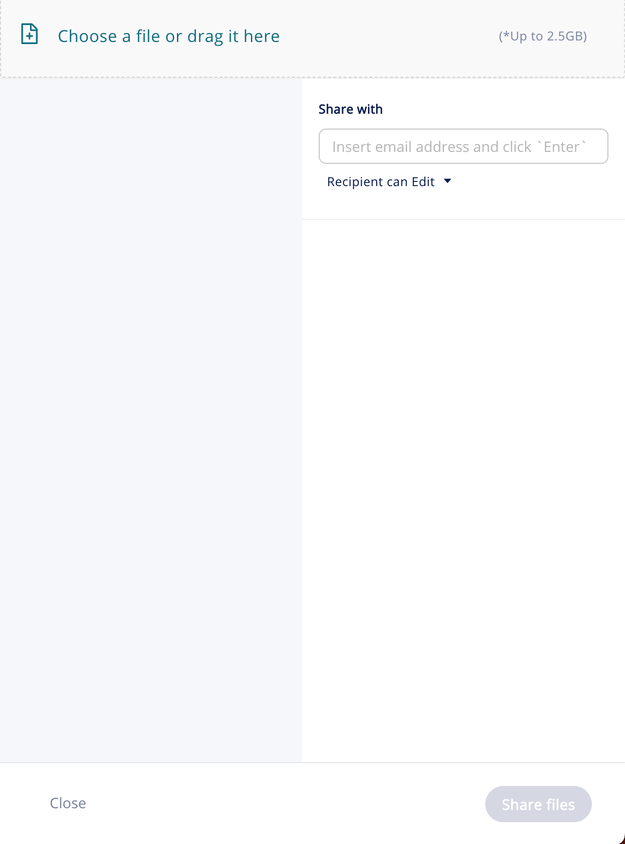

Enter the recipient email address under the ‘Share with’ section and click Add, or click the ‘Enter’ button on your keyboard.
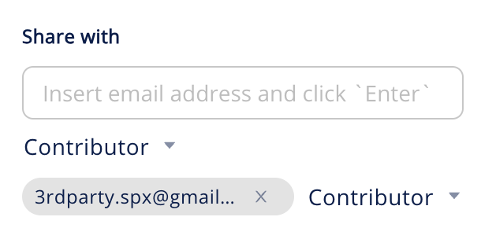

You can change the recipient’s usage permissions within the ‘Contributor’ dropdown and choose if the recipients will receive an email notification from SpecterX
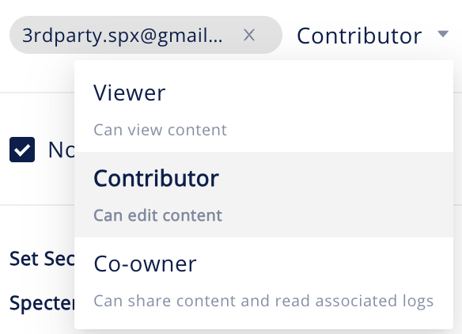

You can adjust the predefined policy (Default) for each file to determine how recipients will access and use the data

You can choose to apply the policy for the entire files/folders you uploaded by clicking the “Set for all” button

In order to share the file, click the ‘Share Files’ button at the bottom right corner


That’s it! You have shared your files successfully.
You may also want to copy the sharing link by clicking the ‘Copy to clipboard’ button, and use the link in your emails and instant messages.

